Fadi Fayez

Health and safety

Interactive Application Proposal for the Manukau Institute of Technology

**Contents**

**1.** **Introduction** 3

**1.1 Health and Safety** 3

**1.2 Solution and Research Question** 3

**1.3 Measurable Organisational Value (MOV)** 3

**1.4 Software Methodology** 3

**2.** **Existing System and Other Applications** 4

**2.1 Current Health and Safety System** 4

**2.2 Existing Applications** 5

**2.2.1 PeopleSafe** 5

**2.2.2** **Learn Workplace Safety** 6

**2.2.3** **Mobile Safety** 7

**2.2.4** **Safety Representative Training** 8

**2.2.5** **Victoria University of Wellington Health and Safety Website** 9

**2.3 Existing Applications Benefits and Faults** 10

**3.** **Software and Research Methodology** 11

**3.1 Software Methodology** 11

**3.2** **Research Methodology** 11

**4.** **Resources** 12

**4.1 Android Studio** 12

**4.2 Office 365** 13

**4.3 Visual Studio** 13

**5.** **Project Risks** 14

**5.1 Time Constraints** 14

**5.2** **Lack of Communication** 14

**5.3** **Hardware Failure** 14

**5.4 Lack of Experience** 14

**6.** **Planning Required** 15

**6.1** **Responsibilities** 15

**7.** **Gantt Chart** 0

**8.** **Conclusion** 0

**9.** **References** 1

# **Introduction**

## **1.1 Health and Safety**

Health and safety refers to guidelines and processes that are implemented within a place of work or communal environment to avoid accident or injury (Health and Safety, n.d.). In New Zealand, companies and individuals must adhere to health and safety procedures by law, as set out in The Health and Safety at Work Act 2015, which makes everyone responsible for their own and others safety (Health and Safety at Work Act 2015, 2017). Due to everybody being responsible for health and safety, this document will propose why it is necessary for an interactive application around health and safety be developed and offered to students attending the Manukau Institute of Technology, to help raise student awareness of their responsibilities at their place of study.

## **1.2 Solution and Research Question**

This project involves improving health and safety procedures at the Manukau Institute of Technology by making it more interactive via a mobile application which will make health and safety awareness more accessible to students. A health and safety video and website are other alternatives that may be implemented if time permits. This application that is being proposed is to answer a very important question; Can a mobile application improve awareness of health and safety for students at the Manukau Institute of Technology?

## **1.3 Measurable Organisational Value (MOV)**

The Measurable Organisational Value (MOV) of this project is targeted towards the social aspect of the Manukau Institute of Technology. This is because students are some of the most important people for the future of New Zealand, as the skills they are going to learn whilst studying, will one day have a positive impact and influence on the future of the country. By giving students the tools to keep themselves and others safe in their place of study, the Manukau Institute of Technology should see a minimum of 50% reduction of student incidents over all three of their current campuses. The health and safety knowledge that they are being given will enable them to identify hazards and suggest ways of minimizing or eliminating these hazards for the safety of everyone. This is especially important for international students, as the health and safety standards in their own country may be vastly different to the standards within New Zealand.

## **1.4 Software Methodology**

Agile and Extreme Programming (XP) are the chosen software methodologies that are going to be used for the develop of the application and website. This is due to requirements that could potentially change during the development lifecycle, the size of the software development team (two people), the short time schedule for development, the necessity for simplicity, and the feedback that the team will constantly be receiving throughout the projects lifetime (Extreme Programming, n.d.; Wells, n.d.).

# **Existing System and Other Applications**

## **2.1 Current Health and Safety System**

The Manukau Institute of Technology currently have a health and safety guide that only staff can view on the employee intranet. When a new staff member starts at the polytechnic, they are required to view these documents and fill out a questionnaire related to this guide, this questionnaire then gets filed under that new employee’s paperwork. Additionally, there is an incident reporting tool available for staff and students on the polytechnics website.

There are several significant problems with this current system.

1. There is no access for students or visitors to view these health and safety guidelines.
2. When a student first starts at the Manukau Institute of Technology, they do not receive a health and safety briefing or instructions on what to do in the event of a fire or emergency.
3. Once the new employee has had their questionnaire filed, there are no yearly follow up meetings identifying new hazards or changes to the guidelines.
4. Students are not instructed on where the incident reporting tool is located, what it entails, or how to use it.
5. Currently, staff are required to read several detailed pages of documentation which is time consuming and can easily be forgotten.
6. Students are not required to fill out a health and safety questionnaire when first starting at the Manukau Institute of Technology so have no idea about hazards, risks, procedures, and responsibilities.

## **2.2 Existing Applications**

There are a large variety of existing mobile applications and websites that feature health and safety and explain its importance. All these applications have their own strengths and weaknesses and encompass health and safety for a large variety of jobs and workplaces. Five of these applications have been carefully selected that relate closely to what the proposed application needed at the Manukau Institute of Technology will feature.

### **2.2.1 PeopleSafe**

The first application that has been chosen for review is called PeopleSafe. It is a monthly subscription service that gives a company access to cloud software and a mobile application (Want Common Sense Health and Safety in Your Business?, 2016). Some of its important features include being able to communicate and have conversations about health and safety with everyone that has the software or mobile application installed, guidelines on setting up and managing the risks in your workplace, access to emergency plans and procedures, fast recording of safety events and new risks, gives every individual the knowledge they need to make a difference, simple navigation, sleek layout, and accessibility from any machine; computer, laptop, smartphone, etc (Clever Online Software, 2016).

Although this software and application have many positive traits, it is not without its downfalls as well. The navigation menu is huge and would easily confuse students about where critical information around health and safety is located, especially for international students. PeopleSafe do not include a health and safety manual or any documentation about what health and safety is, which is an crucial aspect students need to know and understand. On top of this, both the application and the cloud software do not give the user any place to upload documentation or videos that may be important to that company’s place of work.

A screenshot of a computer

Description generated with very high confidence

Fig. 1. (Want Common Sense Health and Safety in Your Business?, 2016)

### **Learn Workplace Safety**

Learn Workplace Safety is a free application offered on the Google Play store which was developed by one man; G. Hoang. It features an in-depth guide around what health and safety is, what hazards and risks are and how to manage them, responsibilities as an individual, and how to train individuals on workplace safety (Hoang, 2018). The developer has included advertisements within the application to be able to offer it to consumers as a free download. Also, a simple design and easy navigation are what makes this application so attractive.

The main aspect of having health and safety documentation available to students within a free application is ultimately what this project requires. However, there are a few of essential features that this application is lacking. After reading all the documentation, a questionnaire should be available to be filled out to make sure the user has understood what they have just read. A video or small game should be offered to make the application more interesting, as many students would get very bored reading pages upon pages of documentation. Lastly, the ability to be able to talk to other students via the application would be a huge improvement. Being able to share thoughts or talk about new risks that have been identified with everyone using the application, would certainly make a workplace a lot safer.

A screenshot of a cell phone

Description generated with very high confidence

Fig. 2. (Hoang, 2018)

### **Mobile Safety**

Red River College in Manitoba, America, employ an application called Mobile Safety for their staff, students and faculty. It features some useful tools like emergency planning and info, safety tips, a personal safety toolbox, important contact information, and Safewalk; a tool that allows an individual to request a security escort if they are on the campus after normal teaching hours (Clarke, 2017). This application has student safety as one of their top priorities and does an excellent job of this, through their easy and understandable navigation menu.

Although this app is excellent in providing safety solutions for students, it is let-down in its lack of documentation around health and safety, e.g. procedures, laws, responsibilities, hazards, and risks. It provides a useful tool for students to identify hazards each day but does not actually explain what a hazard is or how to eliminate, isolate or minimize each hazard (Tattersfield, 2016). This application also does not provide any videos or a questionnaire for students to fill out to make sure each student understands what health and safety is.

A screenshot of a cell phone

Description generated with very high confidence

Fig. 3. (Clarke, 2017)

### **Safety Representative Training**

This application is quite a lot different to all the others that have been reviewed thus far. It provides a platform for students to become a health and safety representative. This is done by studying documentation within the application and completing an examination when the student feels capable in their knowledge of health and safety. There is no pressure on students to complete this examination as it can be done in their own time so will not interfere with their studies. When complete and the student has achieved a pass mark in the examination, they then receive a certificate that verifies them as a health and safety representative (Botes, 2017). Although this does not totally relate to the application that is being proposed, enabling students to become health and safety representatives would be a positive move, as these representatives would not only make the Manukau Institute of Technology safer, but they would be able to help promote the health and safety application to new students.

The only major downfall with this application is, although it is offered in several languages, including English, every country has their own unique health and safety guidelines and laws, and because this was made in South Africa, the guidelines featured in the application may not apply to New Zealand. Further research into the application would be required before pursuing this avenue any further.

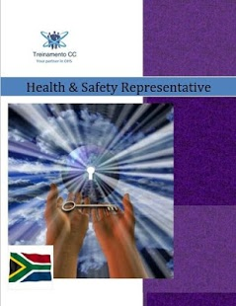

Fig. 4. (Botes, 2017)

### **Victoria University of Wellington Health and Safety Website**

Victoria University is a prominent university located in Wellington, New Zealand. It has a dedicated health and safety section on their main website which is available to browse for staff, students and the public. It offers a training programme, safety video, hazarding reporting form, emergency contacts, and other health and safety related tools. On top of this, the website features personalised health and safety for students, staff, or contractors, something that is very important as health and safety relates differently to each of these groups of people (Health and Safety, 2017). Just by having a quick browse of the websites health and safety page, it is plain to see that Victoria take health and safety very seriously.

The merits of Victoria University’s website far outweigh the negatives, of which, there is only one that needs to be mentioned. The layout of the health and safety page is extremely cluttered. All information that relates to a particular topic, e.g. events, community, associated links, etc. are made into a collection and have their own containers for that content, separating each topic appropriately (Health and Safety, 2017). This is an effective way to organise information, however, each container is sized differently and placed on the webpage in different positions which causes the webpage to seem very cluttered and unattractive.

A screenshot of a social media post

Description generated with very high confidence

Fig. 5. (Health and Safety, 2017)

## **2.3 Existing Applications Benefits and Faults**

All of the applications discussed above have features and functionalities that we would like to use in our application and features that may be of no benefit as well.

The first application discussed; PeopleSafe, has two major features we would benefit from by including in our application. The first is the ability to able to communicate with any or all users of the application in order to have meaningful and organised discussions about health and safety. This would act like a Facebook Messenger or WhatsApp service and would also allow administrators to notify all users of upcoming changes to the app or the health and safety policy. The second is the cloud service that PeopleSafe offer. Our scope currently allows for an Android application and website, however, if more time was permitted, offering a cloud service via the web, that could be downloaded onto a desktop, laptop or tablet computer would be largely beneficial to the entire Manukau Institute of Technology community; not just students. Although both of these features would be extremely valuable to our project, with the time restriction we have, neither of these features are going to be included in our scope, however may be considered for future upgrades to the system we are proposing.

The three applications that we covered; Learn Workplace Safety, Mobile Safety and Safety Representative Training all have their own strengths and weaknesses. All three have a simple and easy to navigate Graphical User Interface (GUI) which we consider is essential to include in our proposed application and website, as these functionalities can be the difference between success or failure for many different types of software. Secondly, all three applications store a large amount of information and documentation, e.g. a health and safety guide, which is another feature that our application absolutely requires. The third and final feature of all three of these applications that we will definitely include in our proposed application is publishing the application on the Google Play Store as a free download. The application is trying to raise student awareness about health and safety and not about turning a profit so advertisements, like the ones in the Learn Workplace Safety application, is a feature that is unnecessary for this project and will not be included in our scope.

The Victoria University’s health and safety section of their website is brilliant. It has many features that will be useful to include in our project and hardly any downfalls. The simple navigation, separation and collection of valuable information, safety video, hyperlinks to other useful websites, and vibrant colour of the website are all features and functionalities that we would like to include in our project. Unfortunately, due to time constraints, we will not be able to include the several useful tools, training and events, or emergency information features that this website has, however, would definitely push for these features in later updates.

# **Software and Research Methodology**

## **3.1 Software Methodology**

The software methodology used in the project are a mix of Agile and Extreme Programming principles. Agile imposes working collaboratively, flexibly and incrementally, and does not impose an individual methodology or framework. There are a number of popular frameworks that Agile adopts and the most popular ones are Kanban, Scrum and Extreme Programming. A lot of Agile teams adopt different elements of each framework when working in an Agile environment, but we will be focusing on the Extreme Programming framework within Agile (Agile Frameworks – Scrum, Kanban and Extreme Programming, 2017).

Extreme Programming is a framework that ensures small teams work collaboratively in brief development cycles and are adaptable to change. It utilizes user stories and intermittent small releases (Agile Frameworks – Scrum, Kanban and Extreme Programming, 2017).

Extreme Programming have twelve core practices and we will be implementing a number of them throughout the lifecycle of our project (Agile Frameworks – Scrum, Kanban and Extreme Programming, 2017). The practices include:

* Test Driven Development
* Pair Programming
* Simple Design
* Planning Game (frequent release and iteration planning)
* Small Releases (with design improvements or working functionally)
* Collective Code Ownership
* Coding Standards

## **Research Methodology**

Qualitative research methodology is going to be used in this project, by analysing the existing health and safety system at the Manukau Institute of Technology and other health and safety applications on the internet. Qualitative research is multi-method in focus, involving an interpretive, naturalistic approach to its subject matter (McLeod, 2008). Seeing that we can’t place qualitative data into numbers or a graph, we went through the existing system at MIT and chosen applications on the internet, taking note of strengths and weaknesses of each application. This resulted in a list of functionalities that we could implement in our application to insure it is effective in raising awareness of health and safety at MIT.

# **Resources**

## **4.1 Android Studio**

Android Studio’s Integrated Development Environment (IDE) is a valuable resource for developing native Android applications on Google’s Android Operating System. Android Studio has a large variety of features that are very useful for the full development lifecycle of an application (Meet Android Studio, n.d.). Some of the features include:

* Refactoring code and quick fixes.
* Lint tools to catch performance and version compatibility problems.
* A rich layout editor that allows users to drag-and-drop UI components, option to preview layouts on multiple screen configurations.
* Android Virtual Device to debug apps on different Android Operating Systems.

Java programming language will be the chosen language that will be used to code this application, which runs on Android studio.

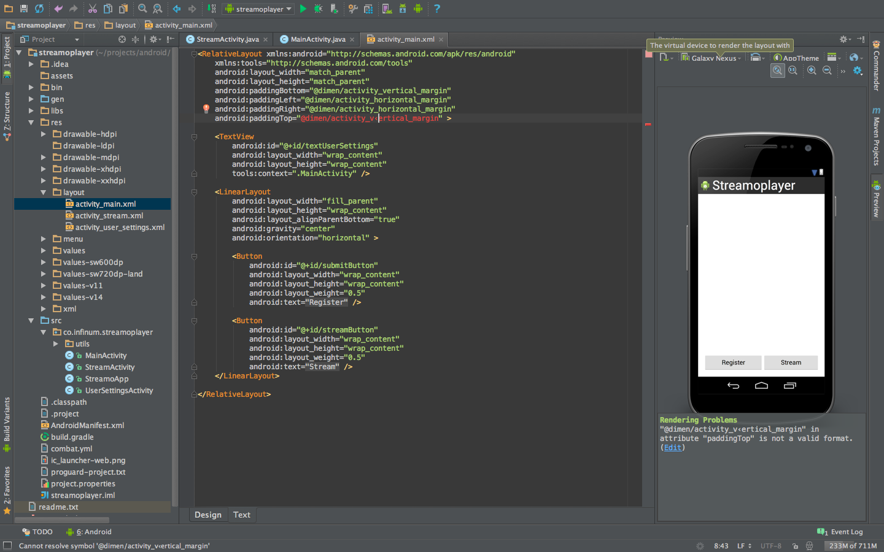

Fig. 6. (Plesac, 2013)

## **4.2 Office 365**

Over the whole process of this project we will be using Microsoft Office 365 many times to complete tasks such as, Word document for proposal, PowerPoint for presentation and email for communication between team members. 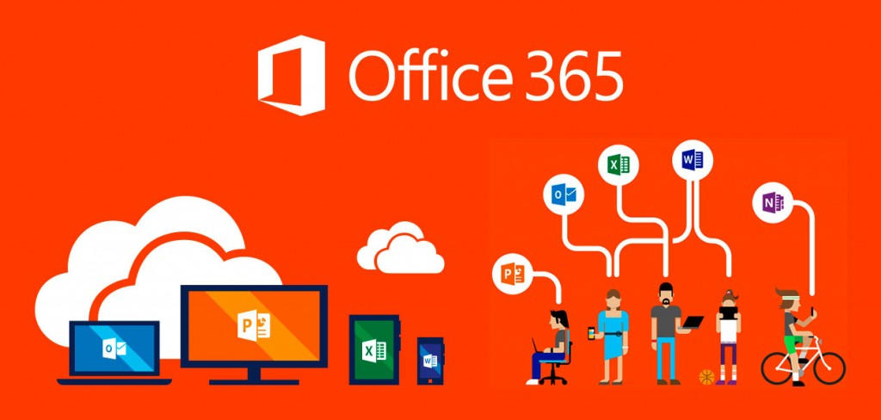

Fig. 7. (Microsoft 365 Education, n.d.)

## **4.3 Visual Studio**

Microsoft Visual Studio will be used as an Integrated Development Environment (IDE) to develop the landing page for our health and safety application. Coding languages used to develop the landing will be HTML for creating the structure of the webpage and CSS for styling the webpage.



Fig. 8. (Visual Studio IDE, n.d.)

# **Project Risks**

This project has several risks which will need to be managed appropriately to produce a quality product by the end of the project deadline.

## **5.1 Time Constraints**

The overall project has been given a total of eight weeks to complete every task set forth. For a project of this magnitude, eight weeks is not a lot of time, especially since this is the first time both Logan and I have undergone a project of this magnitude. To manage this risk, a weekly meeting between Logan and I is imperative to discuss what has been achieved and what has taken longer than expected. On top of that, a Gantt chart has been created to detail exactly what tasks need to be done and by what date. Both the meetings and Gantt chart are important for this project; however, unforeseen problems may arise that will affect our schedule and will need to be managed appropriately.

## **Lack of Communication**

Projects can fail all too often because of communication issues. Methods of communication, e.g. email, phone and face-to-face is one aspect of this risk as communication is interpreted differently between all three of these methods. The other aspect is people. Team members, lecturers, health and safety officers, and stakeholders all have different schedules. This means that if clarification on a part of the project is needed, relevant documentation is required, or just a general discussion is desired, it will generally not happen within a short time period and will need to be scheduled. To manage this risk, Logan and I will need to anticipate required meetings as best we can and organise them as soon as possible. Also, communicating face-to-face as often as we can is also necessary as this has always been the best form of communication.

## **Hardware Failure**

Unfortunately, computers are not perfect and can fail from time to time. A faulty hard drive, corrupt version of Windows, or even dropping and breaking our Android phone that we will use to test our application are some examples. If any of these things were to happen, they would undoubtedly affect our project and schedule. The best way that this risk can be managed is by making backups of our work after every session we spend working on the project.

## **5.4 Lack of Experience**

Logan and I are students that do not have great deal of experience coding, testing, designing or developing. What’s more, we have only had one class to learn Android Studio which is the software we are going to be using to develop our application. This means that both of us will inevitably run into problems whilst coding and will have to do a lot of reading and researching on how to fix these problems. Our maturity, willingness to learn and perseverance are all qualities which will need to be utilized to the fullest to manage this risk.

# **Planning Required**

As project leader, I (Chris Watson) have tried to divide the tasks up evenly so that both Logan and I do a fair amount of work to contribute to the overall project.

## **Responsibilities**

Chris Watson is the project leader and responsible for the following tasks:

1. Organising meetings with lecturer and health and safety officer.
2. Organising weekly minute meetings.
3. PowerPoint presentation for both presentations.
4. Delegating who is talking about what for presentations.
5. Research proposal except Software and Research Methodology and Resources sections.
6. Getting research proposal checked with lecturer and making changes as needed.
7. Gantt chart.
8. Assisting Logan when required with coding and testing.

Logan Shaw is the lead developer and responsible for the following tasks:

1. Software and Research Methodology and Resources sections of the research proposal.
2. Proofreading.
3. Choosing software to develop application and website.
4. Choosing research methodology to follow.
5. Coding and testing a large majority of the website and application but also getting Chris to assist when required.

Both Chris and Logan are responsible for completing these tasks together:

1. Filling in weekly team meeting minutes form.
2. Designing application and website.
3. Producing a video for the software.
4. Completing tasks within the scheduled timeframe.
5. Presentations.

# **Gantt Chart**

A close up of a map

Description generated with high confidence

A screenshot of a computer

Description generated with very high confidence

A screenshot of a cell phone

Description generated with very high confidence

# **Conclusion**

Overall, health and safety for students at the Manukau Institute of Technology is of paramount concern and by proposing these solutions, even if we only slightly improve student life, we believe that we will have achieved our goal. There are many risks that we may encounter along the way and that can have an effect on this project to cause it to ultimately end in failure, however, because health and safety is so important and Logan and I have a passion for learning and completing tough challenges, we have optimism that this new system will be delivered on time and to a high quality.

# **References**

*Agile Frameworks – Scrum, Kanban and Extreme Programming*. (2017, January 12). Retrieved from EPA Developers Guidance: https://developer.epa.gov/guide/templates-guides/agile/agile-frameworks/

Botes, J. (2017, April 11). *Safety Representative Training*. Retrieved from Google Play: https://play.google.com/store/apps/details?id=hsrepresentative.johann.com.healthandsafetyrepresentative

Botes, J (2017, April 11). Image. Safety Representative Training. Retrieved March 10, 2018 from: https://play.google.com/store/apps/details?id=hsrepresentative.johann.com.healthandsafetyrepresentative

Clarke, D. (2017, June 13). *Mobile Safety*. Retrieved from Google Play: https://play.google.com/store/apps/details?id=com.cutcom.apparmor.rrc

Clarke, D. (2017, June 13). Image. Mobile Safety. Retrieved March 2, 2018 from Botes, J (2017, April 11). Image. Safety Representative Training. Retrieved March 10, 2018 from: https://play.google.com/store/apps/details?id=hsrepresentative.johann.com.healthandsafetyrepresentative

*Clever Online Software*. (2016). Retrieved from PeopleSafe: https://www.peoplesafe.co.nz/cloud-based-safety-software/

Denzin, N. &. (1994, .(1994). Handbook of Qualitative Research. Thousand Oaks, CA, US: Sage Publications Inc.). *Handbook of Qualitative Research.* Retrieved from https://www.simplypsychology.org/qualitative-quantitative.html

*Extreme Programming*. (n.d.). Retrieved from Agile Alliance: https://www.agilealliance.org/glossary/xp/#q=~(filters~(postType~(~'post~'aa_book~'aa_event_session~'aa_experience_report~'aa_glossary~'aa_research_paper~'aa_video)~tags~(~'xp))~searchTerm~'~sort~false~sortDirection~'asc~page~1)

*Health and Safety*. (2017, May 9). Retrieved from Victoria University of Wellington: https://www.victoria.ac.nz/healthandsafety

*Health and Safety*. (2017, May 9). Image. Retrieved March 10 2018 from: https://www.victoria.ac.nz/healthandsafet

*Health and Safety at Work Act 2015*. (2017, September 4). Retrieved from Worksafe: https://worksafe.govt.nz/laws-and-regulations/acts/hswa/

*Health and Safety*. (n.d.). Retrieved from English Oxford Living Dictionaries: https://en.oxforddictionaries.com/definition/health_and_safety

Hoang, G. (2018, February 1). *Learn Workplace Safety*. Retrieved from Google Play: https://play.google.com/store/apps/details?id=com.appsgooder.workplacesafety

Hoang, G (2018, February 1). Image. Learn Workplace Safety. Retrieved March 2, 2018 from: https://play.google.com/store/apps/details?id=hsrepresentative.johann.com.healthandsafetyrepresentative

McLeod, S. (2008). *Qualitative vs. Quantitative*. Retrieved from Simply Psychology: https://www.simplypsychology.org/qualitative-quantitative.html

*Meet Android Studio*. (n.d.). Retrieved from Android Studio: https://developer.android.com/studio/intro/index.html

*Microsoft 365 Education*. (n.d.). Retrieved from Microsoft: https://www.microsoft.com/en-us/education/buy-license/microsoft365/default.aspx

Plesac, Ž. (2013, June 18). *Android Studio vs. Eclipse - 1 : 0*. Retrieved from Infinum: https://infinum.co/the-capsized-eight/android-studio-vs-eclipse-1-0

Tattersfield, R. (2016, July 19). *Health and Safety at Work (General Risk and Workplace Management) Regulations 2016*. Retrieved from Safely: http://www.safely.nz/newsroom/health-and-safety-at-work-general-risk-and-workplace-management-regulations-2016

*Visual Studio IDE*. (n.d.). Retrieved from Microsoft: https://www.visualstudio.com/vs/

*Want Common Sense Health and Safety in Your Business?* (2016). Retrieved from PeopleSafe: https://www.peoplesafe.co.nz/

Want Common Sense Health and Safety in Your Business? (2016). Image. Retrieved March 2, 2018 from: https://www.peoplesafe.co.nz/

Wells, D. (n.d.). *When should Extreme Programming be used?* Retrieved from Extreme Programming: http://www.extremeprogramming.org/when.html